# Working with GET Requests:

endpoint : <https://jsonplaceholder.typicode.com/users>

**Check the count of users =10**

pm.expect(Object.keys(pm.response.json()).length).to.eql(18);

# Working with POST Requests:

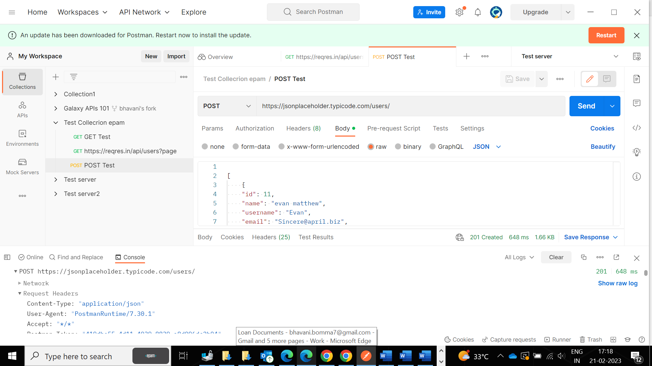

**Petstore:**

**Validation:**

# How to Parameterize Requests

Added url request under global variables

